WORKSHEET 2

**Student Name: Priyansh**

**UID: 20BCS5670**

**Branch: CSE**

**Section: 903-A MM (DWWC- 43)**

**Que-1:** [**How many unattempted problems**](https://www.codechef.com/submit/PRACLIST)

**Code:**

#include <iostream>

#include <cstdlib>

using namespace std;

int main() {

int x,y;

cin>>x;

cin>>y;

cout<<x-y<<endl;

}

**Output:**

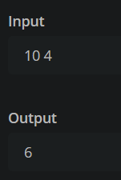

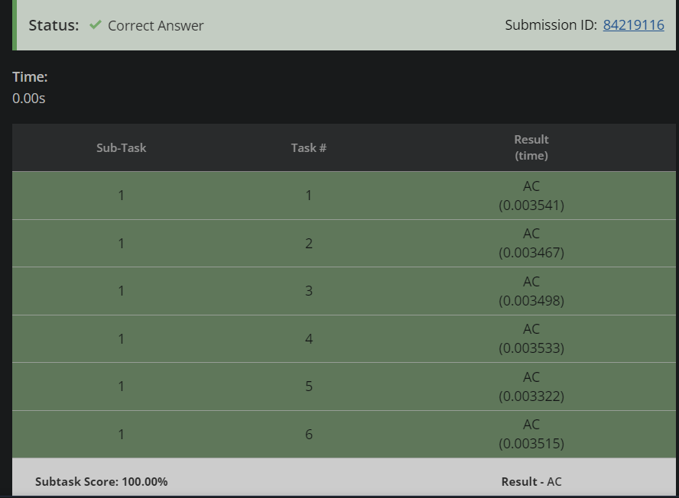

**Que-2:** [**Equal Integers**](https://www.codechef.com/submit/INCREAR?tab=statement)

**Code:**

#include <iostream>

using namespace std;

int main() {

int t;

cin>>t;

while(t--){

int x,y;

cin>>x;

cin>>y;

int diff=abs(x-y);

if(x<=y){

cout<<diff<<endl;

}

else{

int ans=diff/2 + 2*(diff%2);

cout<<ans<<endl;

}

}

return 0;

}

**Output:**

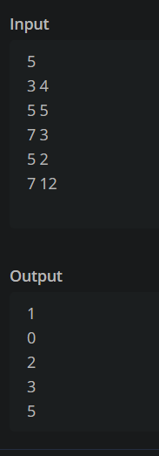

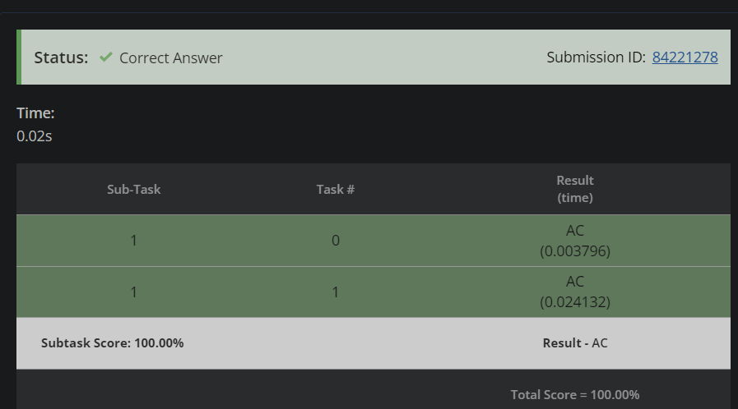

**Que-3:** [**Determine the Winner**](https://www.codechef.com/submit/WINNERR?tab=statement)

**Code:**

#include <iostream>

using namespace std;

int main() {

int t;

cin>>t;

while(t--){

int pa,pb,qa,qb;

cin>>pa;

cin>>pb;

cin>>qa;

cin>>qb;

int p=max(pa,pb);

int q=max(qa,qb);

if(p<q){

cout<<"P"<<endl;

}

else if(p>q){

cout<<"Q"<<endl;

}

else{

cout<<"TIE"<<endl;

}

}

return 0;

}

**Output:**

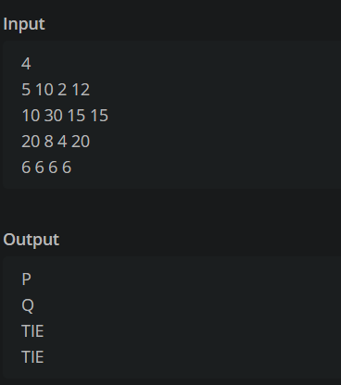

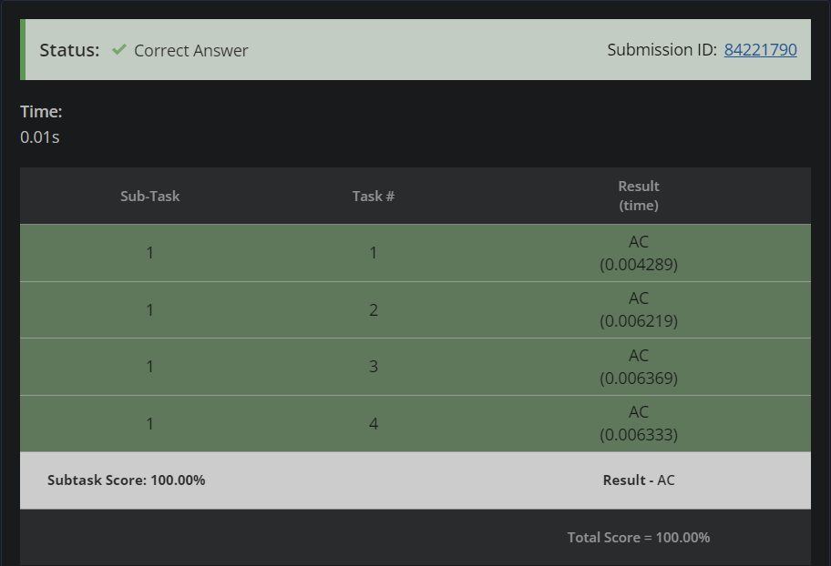

**Que-4:** [**Chef and Brain Speed**](https://www.codechef.com/submit/CBSPEED?tab=statement)

**Code:**

#include <iostream>

using namespace std;

int main() {

int x,y;

cin>>x;

cin>>y;

if(x<y){

cout<<"YES"<<endl;

}

else{

cout<<"NO"<<endl;

}

return 0;

}

**Output:**

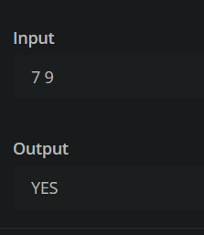

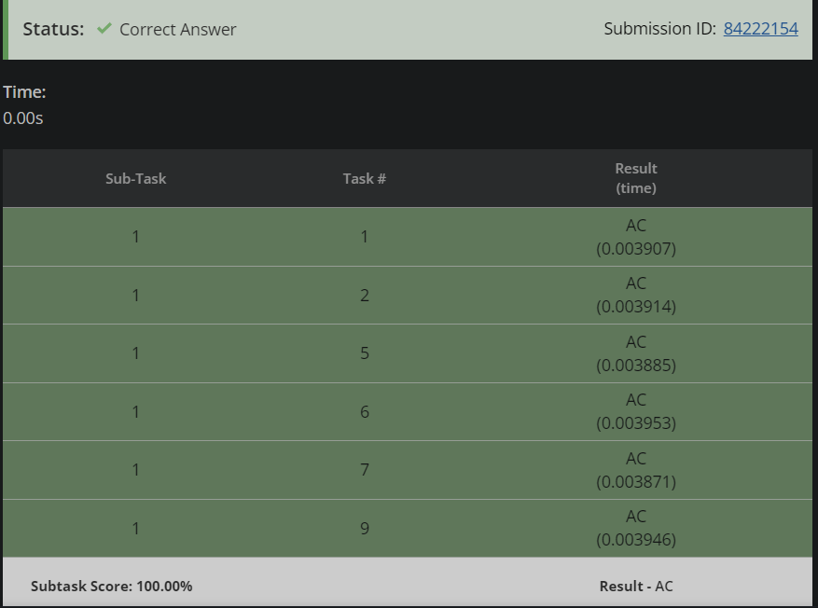

**Que-5:** [**Volume Control**](https://www.codechef.com/submit/VOLCONTROL?tab=statement)

**Code:**

#include <iostream>

#include <cstdlib>

using namespace std;

int main() {

int t;

cin>>t;

while(t--){

int x,y;

cin>>x;

cin>>y;

int ans=abs(x-y);

cout<<ans<<endl;

}

}

**Output:**

